**OUTPUT Week 1 Design Pattern**

Q1: Singleton Pattern

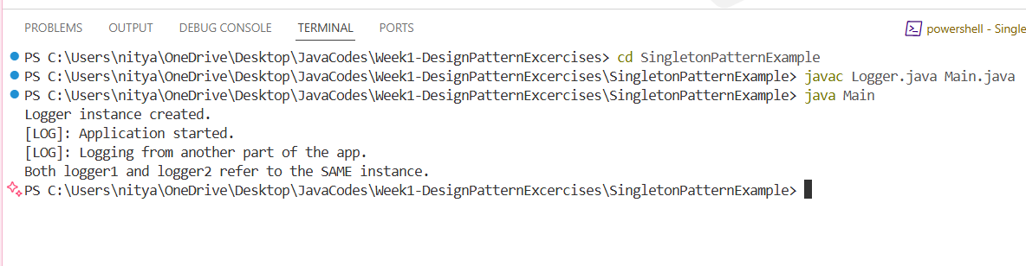

Q2: Factory Method Pattern

